(Approx. 690 words)

Office 2019 and Changes to Office 365
By Nancy DeMarte, 1st Vice President, Sarasota Technology Users Group, FL
May 2019 issue, STUG Monitor
www.thestug.org / ndemarte (at) verizon.net

Office 2019: Microsoft has been releasing new versions of Office every three years for a long time. The newest version, Office 2019, is now available in stores or online. The Home and Student edition for Windows 10 came out in late September 2018. Office for MAC was released on March 3, 2019. The buyer pays one price, which includes updated Word, Excel, and PowerPoint for installation on a single computer. If Office 2019 repeats the support pattern of earlier editions, it also gets regular security updates for ten years, or until 2029. It is also touchscreen compatible.

Included in Office 2019 are a few of the new features which had been available only to Office 365 users. Here are a few of them:

Icons – These scalable vector graphics are organized in a gallery of about 500 small black icons in 30 categories. Icons are located on the Insert tab in Word, Excel, and PowerPoint. They can be enlarged without losing image quality, colored, and given special effects before being inserted into a document, spreadsheet, or presentation.
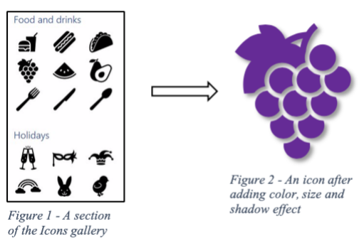
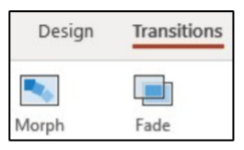
Morph – This clever feature lets you animate a group of objects in a PowerPoint slide. For information about how to set up Morph, click the Transitions tab in PowerPoint. Hover your mouse pointer over Morph, read the information, then click “Tell me More” for the full instructions. With a little practice, it is easy to set up and is a crowd-pleaser.
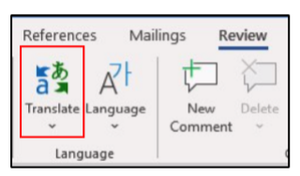
Translate – Located on the Review tab > Language group in Word, Excel and PowerPoint, this feature will translate a section of a document or the whole document to one of several languages. Click the down arrow below Translate to see the list of supported languages.

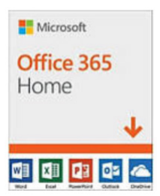
Changes to Office 365 Home: Office 365 is the subscription version of Office. The Home version costs $99.99 per year or $9.99 per month and has several bonuses. Office 365 Personal ($69.99 per year or $6.99 monthly) has all the same bonuses as Home, but for only one computer. Beware of the much lower prices you can find on the Internet. They are likely to give you a fake product.

Some changes in Office 365 took effect beginning in October 2018. It appears that Office 365 is becoming more Internet-based than it was in the past. Office 365 Home can now be installed on six computers (Windows or Mac) plus other devices, plus phones and tablets up to 10.1” screens. However, you can only sign into five devices at one time. If you try to sign into a sixth device, you will get a “limit reached” message and will have to sign out of a device.

Signing into your Microsoft account is the only way to activate Office 365. Once you sign in, Microsoft keeps you signed in until you sign out, with a recommendation that you stay signed in on the devices you use the most. If you sign out, you will lose some Office features. If you have no Internet connection, you will be able to use Office 365 for 30 days before being deactivated.

Each of the six installations still gets a terabyte (1000 gigabytes) of cloud storage in OneDrive, the Microsoft cloud storage area. You can access OneDrive from any computer at any location by signing into your Microsoft account. Office 365 also gets monthly security and feature updates.

For those who want to have access to Office without buying the boxed version (Office 2019) or subscribing to Office 365, Microsoft also offers free Office Online to anyone who has a Microsoft account. The online version runs in an Internet browser, but editing is limited, and you cannot save files created on the web to your computer. Another option is installing the MS mobile apps for iOS or Android phones and tablets, which currently are free for home use.

Microsoft Office is a popular office suite. With the several options available, depending on your need, you can probably find a way to get this feature-filled suite.

